**PROJECT Bank record generations**

**Objective** To write a program that performs data analysis from class objects created in lab #2

**When BankRecordTest is initiated**



**Exception if file is not available**



**AVERAGE INCOME PER LOCATION**

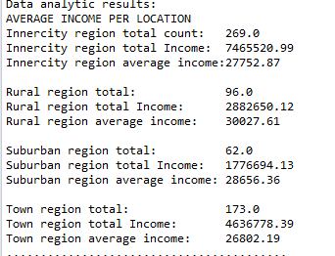

**MINIMUM AND MAXIMUM INCOME**

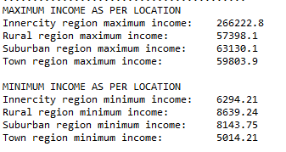

**MINIMUM AND MAXIMUM AGE**



**NUMBER OF FEMALES WITH BOTH A MORTGAGE AND SAVINGS ACCOUNT PER LOCATION**

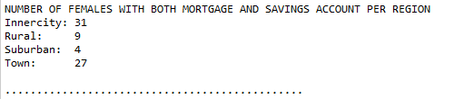

**NUMBER OF MALES WITH BOTH CAR AND 1 CHILD PER LOCATION**

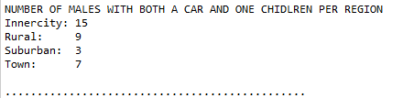

**File which holds the output of the results**

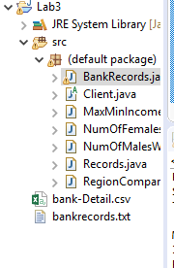

**File which holds the output of the results:**

